2403a51254

Laxmi prasanna

**AI-ASSISTED-CODING**

**Lab exam-1**

**QUESTION 1:**

Write a python code to calculate the sum of odd and even numbers in given list using github copilot along with vs code.use zero shot prompting.

**PROMPT:**

*“generate a python code to calculate the sum of odd and even numbers in given list.”*

*List:*

*Numbers=[1,2,3,4,5,6]*

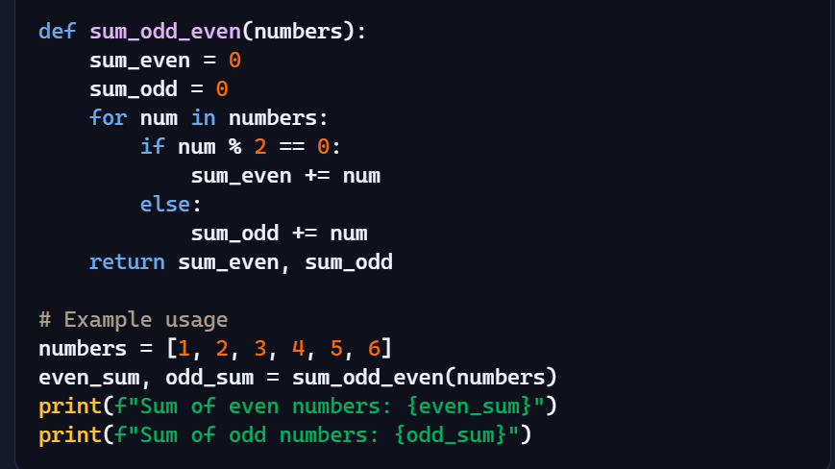

**Output:**

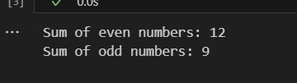

**QUESTION 2:**

Write a python code for given a list of integers.Remove duplicates and print the sorted result.github copilate along with vs code use one shot prompting.

**Prompt:**

**“***generate python code for given a list of integers.Remove duplicates and print the sorted result”*

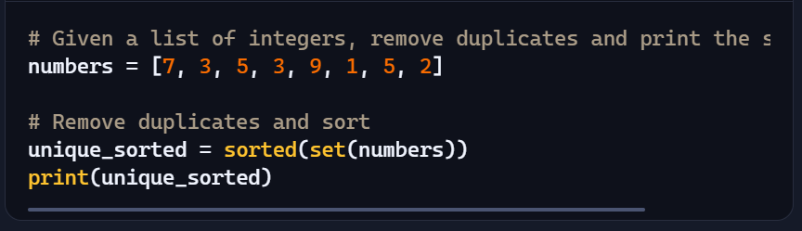

**Output:**

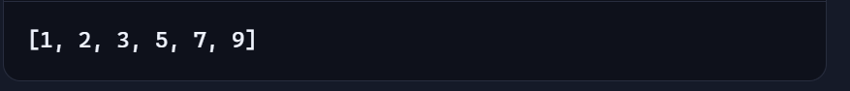

**QUESTION 3:**

Write a python function that converts the tempertature between Celsius,fahrenbeit,and kelvin based on user choice use the cursor ai tool use few shot prompting

**Prompt:**

*“Generate a python function that converts the tempertature between Celsius,fahrenbeit,and kelvin based on user choice”*

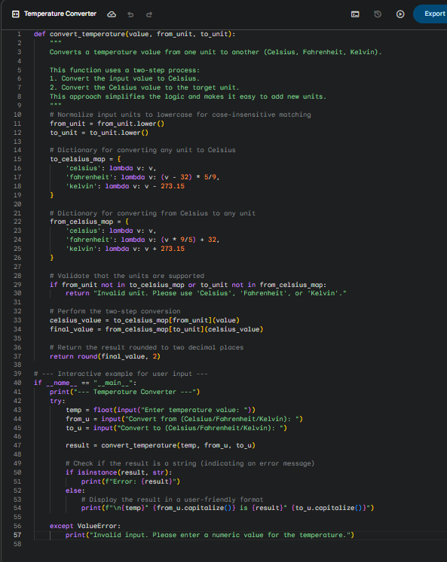

***Output:***

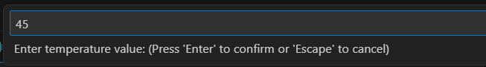

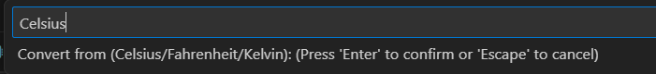

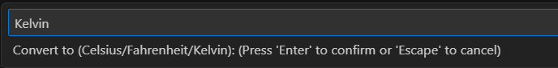

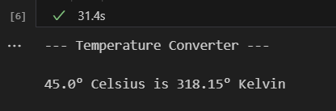

QUESTON 4:

Write a python function to remove punctuation convert to lowercase and remove stop words from a given text use the cursor ai tool use zeroshot prompting

**Prompt:**

*“Generate a python function to remove punctuation convert to lowercase and remove stop words from a given text.”*

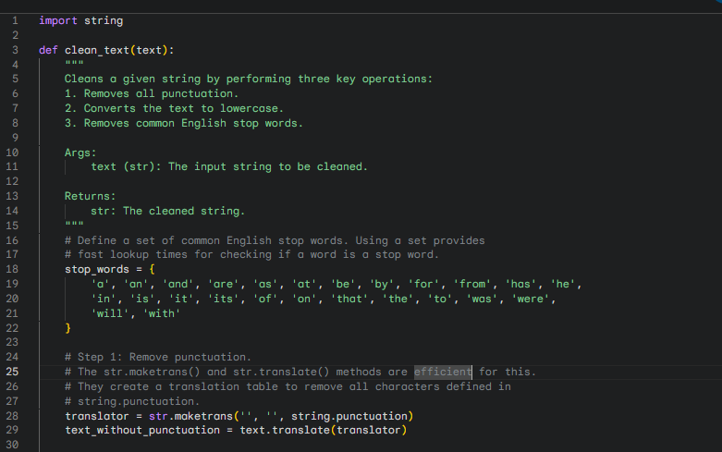

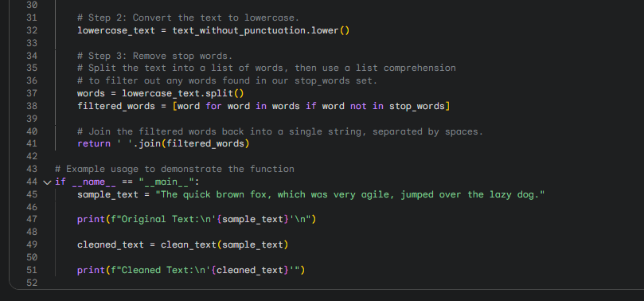

**Output:**

